Argus-AI
A Privacy-First Continuous Vulnerability Assessment and Patch-Recommendation Agent
White Paper — Version 0.1
MS Information Security · Military College of Signals, NUST · Rawalpindi
June 2026
ABSTRACT
Argus-AI is an autonomous vulnerability-assessment and patch-recommendation agent that implements the scan–validate–patch–rescan loop popularised by cloud agents such as OpenAI Aardvark and Anthropic Claude Security, but executes every reasoning step on local language models. The agent is built on the Privacy-First LLM Pentesting Framework (PLPF), which the underlying thesis develops and validates empirically. Argus-AI is designed for environments in which engagement data — target identifiers, scan output, discovered vulnerabilities, credentials — cannot be transmitted to commercial cloud providers, including defence networks and operators of Critical Information Infrastructure under Pakistan’s National Cyber Security Policy 2021. This white paper documents the agent’s working principles, four-stage closed loop, sandbox boundary, LLM integration strategy, and current implementation as a Python orchestrator, with a planned migration path onto the OpenClaw open-source agent framework.

1. Introduction
Modern penetration testing increasingly relies on large language models to translate operator intent into shell commands, interpret tool output, and suggest follow-on actions. The dominant approach — used by GitHub Copilot Security, OpenAI Aardvark, and Anthropic Claude Security — routes prompts and source artefacts to cloud inference. For commercial engagements bound by non-disclosure obligations, defence networks, and Critical Information Infrastructure assessments, this transmission is operationally and legally incompatible with the confidentiality requirements of the engagement.
The accompanying MS thesis, Beyond the Cloud, empirically validates an alternative deployment pattern in which the same offensive workflows can be driven by locally hosted LLMs under three architectures: cloud-hosted (Gemini CLI), local conversational (Ollama with Gemma 3:12B), and local stateless (ShellGPT with LLaMA 3:8B). The central empirical finding is that deployment architecture, not model scale, determines field-deployable performance under privacy constraints.
Argus-AI is the applied artefact derived from that thesis. It operationalises the validated architectures into a continuous, closed-loop agent that discovers vulnerabilities, verifies them by proof-of-exploit, proposes patches, and re-scans to confirm resolution — all without transmitting engagement data outside the assessment perimeter. This paper documents how Argus-AI works, the principles it is built on, the sandbox boundary that contains validation, the strategy for integrating different local LLMs, and the system on which the current prototype was developed.

2. Working Principles
Four design principles govern every component of Argus-AI. They are described first because most of the architectural choices that follow are direct consequences of these commitments.

2.1 Privacy by construction
Every LLM call targets a local inference endpoint, typically an Ollama daemon listening on localhost. No code path in the agent contacts a third-party API. This is not a configurable preference: it is the default and the only supported mode. If the local backend is unreachable, the agent halts with an explicit error rather than falling back to any remote service.

2.2 Stateless command generation
Argus-AI’s Discovery and Re-scan stages issue single-shot prompts with no conversation history. This mirrors ShellGPT’s --shell mode, which the thesis identifies as the mechanism that allows locally hosted models to generate security-sensitive commands reliably. Persistent conversational context progressively accumulates safety-alignment refusal in instruction-tuned models, an effect the thesis terms guardrail amplification. Stateless single-shot prompting structurally prevents this accumulation.

2.3 Validation as a structural defence against hallucination
Local language models can fabricate scan results, invent CVE identifiers, or misclassify target operating systems. A naive agent that acts on these outputs would propagate hallucinated findings into patch recommendations. Argus-AI inserts a validation stage between discovery and patching: every candidate finding must be reproduced by a verification command executed in an isolated sandbox, and judged confirmed only on the basis of corroborating evidence in the verification output. An unverifiable finding never reaches the patch stage, so a fabricated discovery cannot drive a fabricated patch.

2.4 Human authority over consequential action
Argus-AI never applies a remediation autonomously. For every confirmed finding, the proposed patch is surfaced to a human operator who must explicitly authorise application. The default authoriser denies all patches. This places the agent in the role of a research assistant, not an autonomous administrator, and aligns the system with the responsible-use expectations of authorised-testing tooling.

3. System Architecture: The Four-Stage Closed Loop
Argus-AI is structured as a closed iterative loop with four stages. Figure 1 shows the full architecture, including the trust perimeter and the gates between stages.
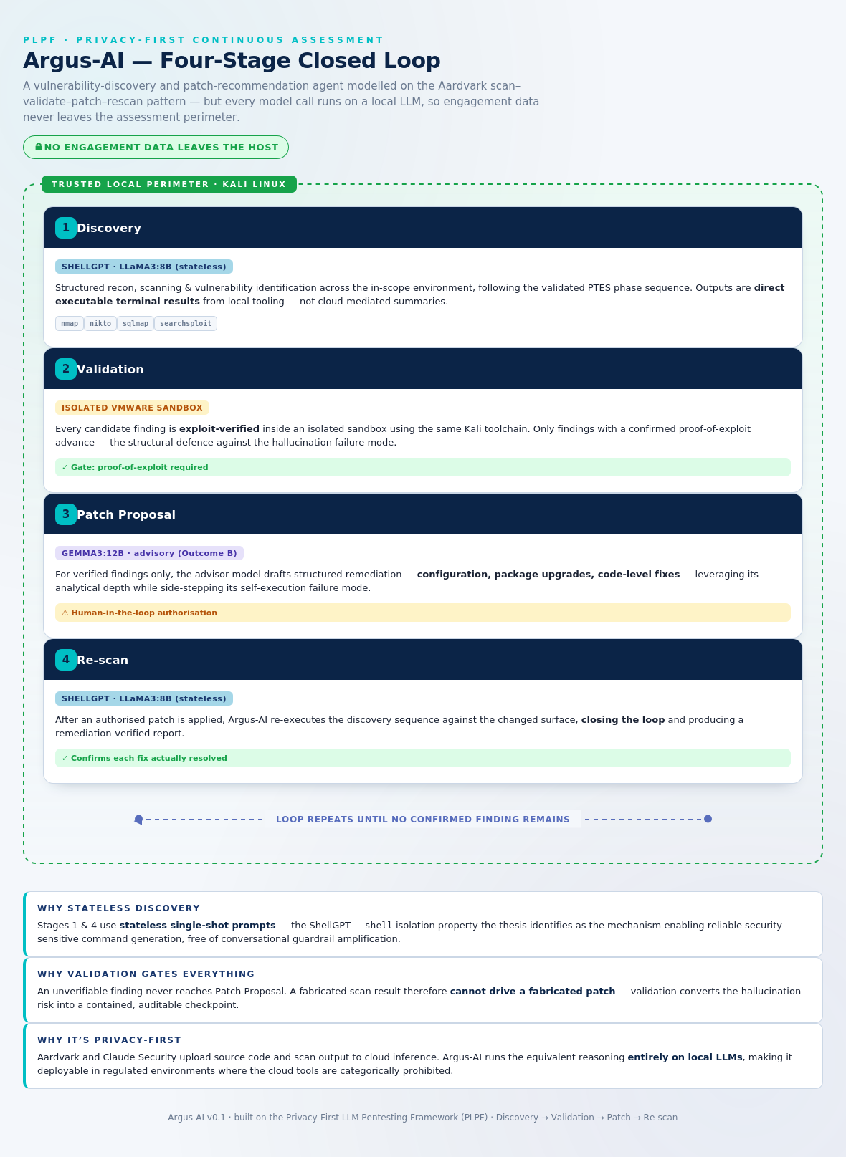
Figure 1. Argus-AI four-stage closed loop. All four stages execute inside the trusted local perimeter; engagement data does not cross the perimeter at any point.

3.1 Stage 1 — Discovery
The Discovery stage performs structured reconnaissance, scanning, and vulnerability identification across the in-scope environment, following the PTES phase sequence (recon, scanning and enumeration, vulnerability identification). For each phase, the executor model receives a single-shot prompt naming the target and the phase, and returns one shell command drawn from an allowlist of standard offensive tools: nmap, nikto, sqlmap, searchsploit, gobuster, whatweb, enum4linux. The command is parsed, validated against the allowlist, blocked if it contains shell-chaining metacharacters, and then executed locally. The raw output is captured and passed to a second prompt that asks the model to produce a structured JSON finding (title, description, severity). Findings with empty output or non-parseable JSON are discarded.

3.2 Stage 2 — Validation
Each candidate finding is exploit-verified inside the sandbox boundary described in Section 4. The model generates a verification command intended to either reproduce the vulnerability or disconfirm it. The verification command runs with a hard timeout, in the sandbox working directory. After execution, a separate judge prompt asks the model to declare whether the verification output confirms the finding, with strictly YES or NO as the only valid responses. Only findings receiving an affirmative judge response, supported by non-empty verification output and a clean exit code, advance to the patch stage.

3.3 Stage 3 — Patch Proposal
For confirmed findings only, the advisor model produces structured remediation. The advisor is configured in pure analytical mode and does not generate executable artefacts. The prompt requires the model to produce three labelled sections: configuration changes, package or version upgrades, and code-level fixes. This separation is deliberate. The thesis documents a failure mode in Gemma 3:12B in which conversational-mode use of the same model produces fabricated execution claims; restricting the model to advisory output side-steps that failure mode while exploiting the model’s analytical strength for remediation reasoning.

3.4 Stage 4 — Re-scan
After a human-authorised patch is applied, Argus-AI re-executes the Discovery sequence against the modified target surface and re-runs Validation on the resulting findings. Each previously confirmed finding is marked resolved if its title no longer appears among the confirmed findings of the rescan, and unresolved otherwise. The loop then either repeats (if confirmed findings remain) or terminates with a remediation-verified report.

4. Sandbox Environment
The sandbox boundary contains the Validation stage. Its purpose is twofold: to prevent verification commands from interacting with the operator’s host beyond the intended scope, and to provide a clean, reproducible execution context that does not leak state across runs.

4.1 Boundary model
Argus-AI defines the sandbox as a single working directory, a hard per-command wall-clock timeout, and a tool allowlist. Verification commands are launched as subprocesses with shlex-parsed argument arrays — never as shell strings — with cwd set to the sandbox working directory. Shell chaining metacharacters (semicolons, pipes, backticks, command substitution) are blocked at command-generation time. The timeout terminates any verification that does not complete within the configured budget.

4.2 Recommended deployment: VM-level isolation
For thesis experiments, and for any deployment beyond a closed laboratory, the sandbox working directory is hosted inside a dedicated Kali Linux virtual machine that is network-isolated from the operator’s primary host. This is the topology validated in the thesis: VMware Workstation on a Windows host, with Metasploitable 2, DVWA, and HackTheBox MonitorsFour as target VMs on a host-only network segment. The Argus-AI process runs inside the Kali VM; verification commands execute against the targets across the host-only network; nothing crosses to the production network of the operator’s laptop.

4.3 Scope authorisation
Independently of the sandbox, Argus-AI enforces an explicit scope-authorisation gate. The configuration carries a list of authorised target hosts and a boolean confirming the operator holds written authorisation to test them. With either unset, the agent refuses to run. This is a redundant safeguard layered on top of the network isolation: even if a misconfigured VM allows packets to a non-target, the agent itself will not generate commands against an unlisted host.

5. LLM Integration
Argus-AI separates the executor role (Discovery and Re-scan) from the advisor role (Patch Proposal). The two roles have different requirements, and the agent is built so either can be swapped independently.

5.1 Executor model requirements
The executor must produce single-line shell commands with no commentary, no markdown fences, and no chain-of-thought. Its sampling temperature is held at 0.0 by default to maximise determinism for reproducibility. The reference configuration is LLaMA 3:8B accessed in stateless single-shot mode, but any instruction-tuned local model with comparable shell-command competence is supported. Strong alternatives that fit a 12 GB VRAM budget include Qwen 2.5-Coder 7B, which the open community currently ranks higher than LLaMA 3:8B on shell-command syntax cleanliness, and Mistral-Nemo 12B at moderate quantisation.

5.2 Advisor model requirements
The advisor must produce long-form structured remediation with explicit section labelling. Sampling temperature is set higher (0.3 by default) because some lexical variation across phrasings is desirable in remediation prose. The reference configuration is Gemma 3:12B in advisory mode; alternatives that fit the same hardware envelope include Qwen 2.5-Coder 14B at Q4 quantisation and Mistral-Nemo 12B.

5.3 Switching models
Model selection is configuration, not code. Three interchangeable methods are supported:
- Command-line flags at invocation time, via --executor-model and --advisor-model.
- Environment variables, read at startup: ARGUS_EXECUTOR_MODEL, ARGUS_ADVISOR_MODEL, ARGUS_OLLAMA_HOST.
- Programmatic configuration through the ArgusConfig dataclass when Argus-AI is embedded in another Python program.
Any model name passed must already be pulled into the local Ollama daemon. If the model is not present, the agent fails at the first inference call with a message naming the missing model and the exact ollama pull command required to obtain it. The agent never silently downloads or substitutes models.

5.4 Model-scale discipline for empirical work
When Argus-AI is used as the harness for further empirical work — for example, to compare a new local model against the LLaMA 3 / Gemma 3 baseline — the agent must be configured with the new model in only one role at a time, holding the other constant. The thesis explicitly identifies the conflation of model and architecture as a methodological gap in prior work; preserving that discipline in the Argus-AI harness is required if results are to be attributable to the variable under test.

6. Implementation

6.1 Current implementation: custom Python orchestrator
The Argus-AI v0.1 prototype is implemented as a self-contained Python package using only the Python 3.10+ standard library. No third-party Python dependencies are required; the only external requirements are a running Ollama daemon and the Kali Linux security toolchain on PATH. The package is structured as follows:
argus/
__init__.py public API
config.py configuration + scope-authorisation gate
llm.py local Ollama client (no cloud calls)
models.py Finding / Command / LoopResult data models
stages.py the four stages of the closed loop
orchestrator.py closed-loop composition + patch-authorisation gate
report.py Markdown and JSON report generation
cli.py command-line interface
This architecture was chosen for the prototype because it removes every variable not strictly required by the four-stage loop. The dependency surface is minimal, the audit footprint is small, and every line that touches the LLM, the target, or the filesystem is in one of seven readable files. The orchestrator composes the four stages, threads the Finding objects through them, and gates patch application on an operator callback.

6.2 Planned migration: OpenClaw substrate
OpenClaw, originally released as Clawdbot in November 2025 and renamed in January 2026, is an open-source framework for running agentic AI on local hardware. It provides a heartbeat daemon for proactive task execution, a SOUL.md system-prompt file as the agent’s persistent identity layer, a plugin architecture for tool access, and an Active Memory system for cross-session state. The framework has become one of the fastest-growing open-source projects to date and has accumulated substantial production engineering around the agent lifecycle that a custom orchestrator does not benefit from.
Argus-AI is scoped to migrate onto OpenClaw as its substrate in the next development cycle. Under that migration, the four-stage loop becomes an OpenClaw skill rather than a standalone orchestrator. The mapping is direct:
- Stage prompts move into a SOUL.md identity file scoped to the offensive-security advisor role, with the privacy-first principles encoded as the agent’s persistent identity.
- Tool integrations (nmap, nikto, sqlmap, searchsploit, the Ollama executor and advisor models) move into OpenClaw plugins with explicit allowlists and timeout budgets.
- The closed loop is expressed as an OpenClaw task flow under the Task Brain scheduler introduced in the 2026.4 release, gaining unified lifecycle management, heartbeat-driven recovery, and the openclaw flows list / show / cancel command surface.
- The validation sandbox boundary continues to be enforced at the VM level (Kali in VMware), with OpenClaw’s subprocess invocations bounded by the same allowlist and timeout configuration that the current orchestrator applies.
The migration is deferred to a subsequent version because the v0.1 prototype must remain auditable in its current minimal form for the thesis defence. Adopting a 250,000-star upstream as a runtime dependency before the empirical baseline is locked would introduce a moving substrate beneath the experiments. OpenClaw migration is therefore documented as the planned production path; v0.1 remains the validated research artefact.

6.3 Development system
Argus-AI v0.1 was developed on Windows 11 Pro with 32 GB RAM and an Intel i5-1135G7, with the agent itself executing inside a Kali Linux 2025.4 virtual machine on VMware Workstation. The Ollama daemon serves models on the Windows host across the host-only network so that virtualisation overhead does not compound model inference latency. The current host has only integrated Iris Xe graphics, which restricts inference to CPU and makes the full experimental matrix impractical without a discrete GPU; allocation of a consumer-grade NVIDIA GPU with 12 GB or more VRAM (RTX 3060 or 4060 class) is the hardware change required to bring inference to interactive latency.

7. Use Cases
Argus-AI is built for environments where the cloud-hosted alternative is categorically prohibited rather than merely inconvenient. Three concrete settings illustrate this.

7.1 Critical Information Infrastructure assessment
Pakistan’s National Cyber Security Policy 2021 designates telecommunications, finance, energy, water, and healthcare as Critical Information Infrastructure (CII) sectors. The policy explicitly treats a cyber-attack on CII as an act of aggression against national sovereignty and mandates indigenous capability for protection of these sectors. Engagement data from CII assessments — network topology, exposed services, discovered vulnerabilities — cannot defensibly be routed through commercial cloud LLM providers. Argus-AI provides an indigenous, fully local alternative aligned with NCSP-2021 objectives and PKCERT’s defensive mandate.

7.2 Defence-network internal assessment
Internal red-team engagements against defence networks operate under classification regimes that prohibit external transmission of any engagement artefact. Argus-AI’s on-host inference and explicit refusal to contact non-local endpoints make it deployable in segments where cloud agents cannot be installed at all.

7.3 Commercial engagements under binding NDA
Commercial pentest engagements typically carry binding non-disclosure obligations covering target environment, discovered vulnerabilities, and exploitation paths. Argus-AI provides the productivity gains of LLM-assisted assessment without putting NDA-covered data on the wire to a third party.

8. Limitations
Three limitations of the v0.1 prototype warrant explicit declaration.
First, the agent inherits the capability ceiling of its local executor model. LLaMA 3:8B in stateless mode generates clean commands but does not match the analytical depth of a GPT-5-class cloud model. Argus-AI is positioned as the privacy-preserving option, not the capability-maximising option.
Second, the sandbox boundary is a process-level boundary inside a VM, not a kernel-level isolation primitive. A determined adversary in possession of a sandbox-escape exploit against the operator’s tooling could in principle escape, just as they could against any pentest workflow that runs untrusted target output through local interpreters. VM-level isolation is the recommended deployment topology.
Third, the v0.1 prototype is single-target. The OpenClaw migration documented in Section 6.2 will introduce multi-target concurrency through the Task Brain scheduler; until then, parallel assessment of multiple targets requires multiple instances of the agent.

9. Future Work
Beyond the OpenClaw migration described in Section 6.2, the following extensions are scoped:
- Quantitative validation of the four-stage loop against a labelled benchmark of known vulnerabilities, reporting precision and recall of confirmed findings, false-positive rate of patch proposals, and end-to-end loop convergence time.
- Empirical comparison of executor model alternatives (Qwen 2.5-Coder 7B, Mistral-Nemo 12B) holding the architecture constant, contributing the controlled-variable extension to the thesis’s Future Work section.
- Integration with PKCERT’s national vulnerability intelligence feeds, enabling Argus-AI to enrich its Discovery prompts with locally relevant CVE context without external API calls.
- A multi-target orchestration mode that uses OpenClaw’s Task Brain to manage assessment of an entire CII segment from a single operator console, with per-target trust-zone enforcement.

10. Conclusion
Argus-AI demonstrates that the closed-loop scan–validate–patch–rescan pattern, popularised by frontier cloud agents, can be implemented on locally hosted language models under strict privacy constraints. The agent’s value proposition is structural rather than competitive: it is not built to match Aardvark’s capability ceiling, but to operate in the deployment regimes where Aardvark and equivalent cloud agents are categorically prohibited. By executing every inference call on local hardware, gating every patch on a confirmed proof-of-exploit, and surfacing every consequential action for human authorisation, Argus-AI extends LLM-assisted security tooling into environments — defence networks, CII operators, NDA-bound commercial engagements — where cloud agents simply cannot go. Combined with the empirical findings of the underlying thesis, it provides an indigenous, defensible foundation for continuous assessment under Pakistan’s National Cyber Security Policy 2021 and analogous regulatory regimes.

References
[1] M. Z. Hanif, “Beyond the Cloud: An Empirical Comparison of Cloud-Hosted and Locally Deployed LLMs for Privacy-Sensitive Automated Penetration Testing,” MS thesis, Military College of Signals, NUST, 2026.
[2] OpenAI, “Introducing Aardvark: OpenAI’s agentic security researcher,” OpenAI, 2025 (rebranded as Codex Security, 2026).
[3] Anthropic, “Claude for security research and vulnerability detection,” Anthropic product documentation, 2026.
[4] Government of Pakistan, Ministry of Information Technology and Telecommunication, “National Cyber Security Policy 2021,” Islamabad, 2021.
[5] P. Steinberger et al., “OpenClaw: open-source self-hosted AI agent framework,” 2025–2026. docs.openclaw.ai.
[6] G. Deng et al., “PentestGPT: Evaluating and harnessing LLMs for automated penetration testing,” in Proc. 33rd USENIX Security Symposium, 2024, pp. 847–864.
[7] M. Zaydi and Y. Maleh, “Empowering red teams with generative AI,” EDPACS, vol. 70, no. 2, pp. 41–66, 2025.
[8] A. Happe, A. Kaplan, and J. Cito, “LLMs as hackers: Autonomous Linux privilege escalation attacks,” ACM Trans. Privacy and Security, 2025.

